Website Audit Report
2025
Site Name
https://sukhman456.github.io/fitness-website/

Areas of Coverage
Performance Audit
- GT Metrix results
- Google Design scores
- Page Size Details
- Page Speed Details
- Scope of Optimization

Security Audit
- Site Information
- Server Information
- Malware Status
- Blacklist Status
- Site Upgrades Status
SEO Performance
- Site SEO Score
- Score Comparison
- Optimum SEO Score

Performance Audit
Google Page Speed Scores
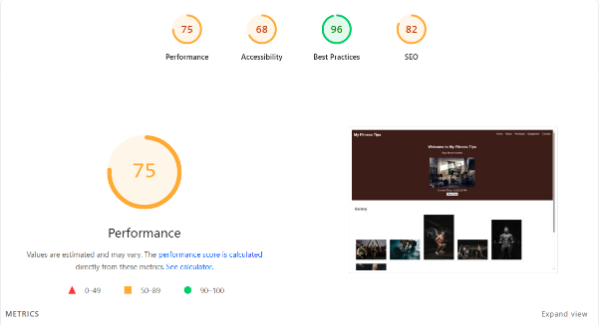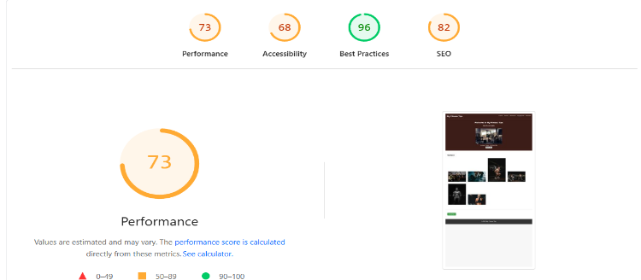
Desktop Mobile

Page Size Details

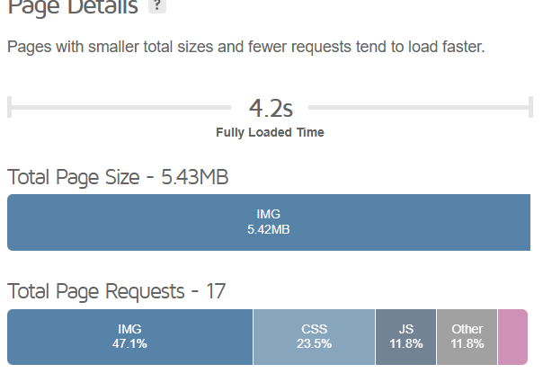
Page Speed Details
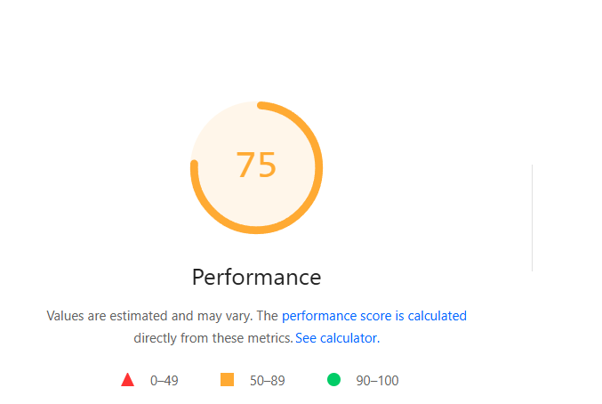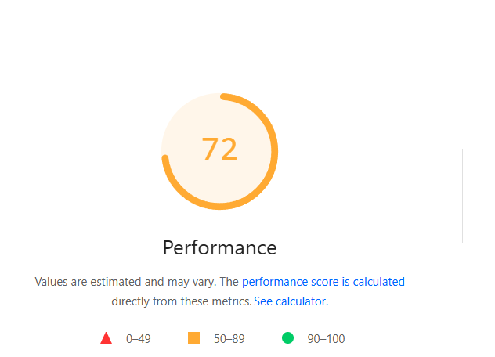
Desktop Mobile
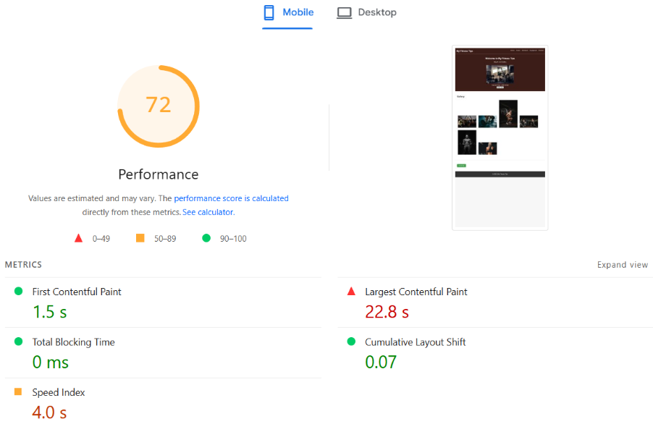

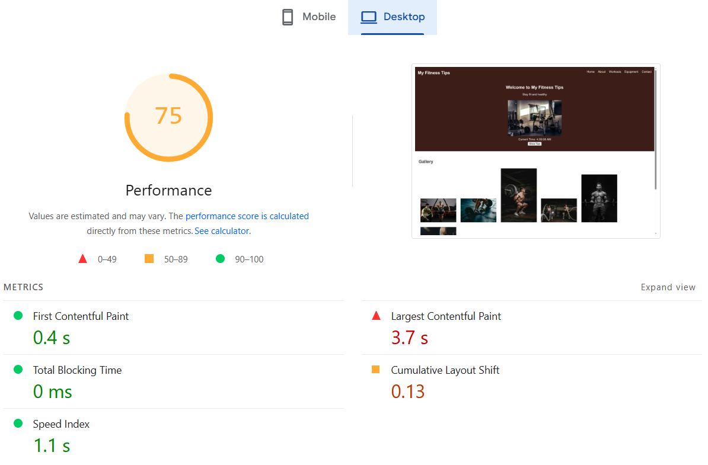

Scope of Optimization:

- Avoid large layout shifts
- Properly size images
- Eliminate render blocking resources
- Largest Contentful Paint element
- Serve images in next-gen formats
- Avoid enormous network payloads

1.Avoid large layout shifts

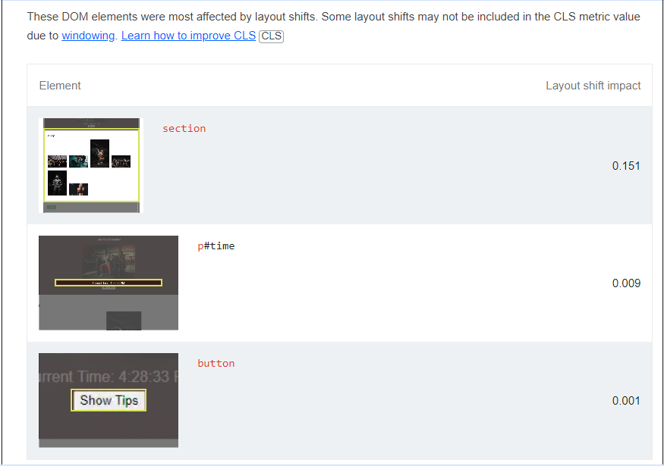

2.Properly size images
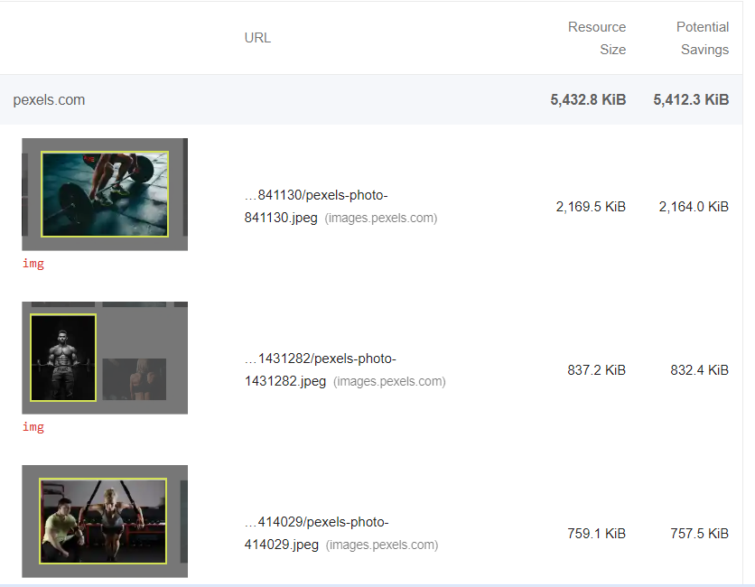

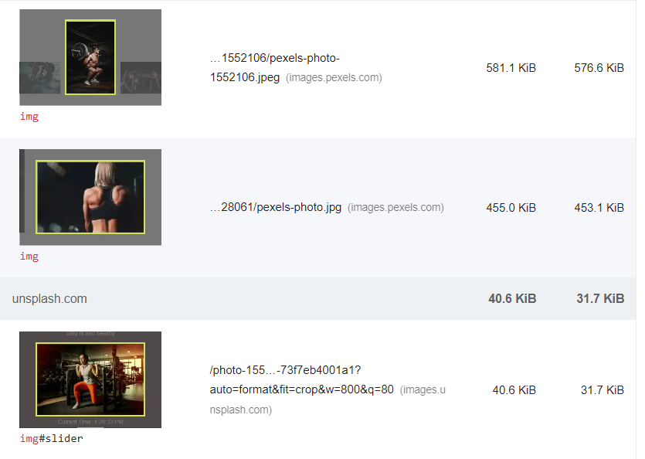

3.Eliminate render blocking resources
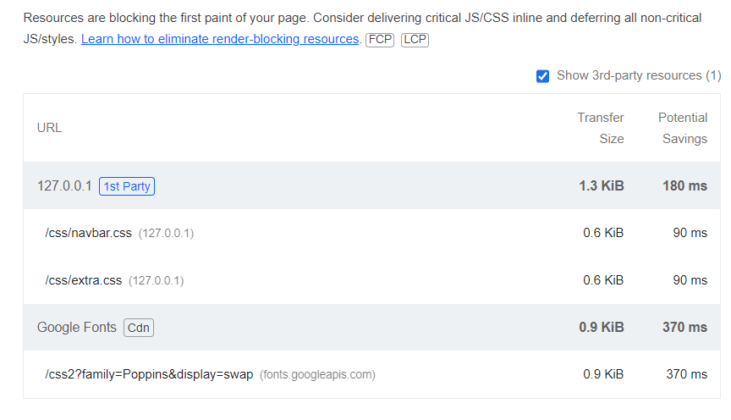
4.Largest contentful paint element
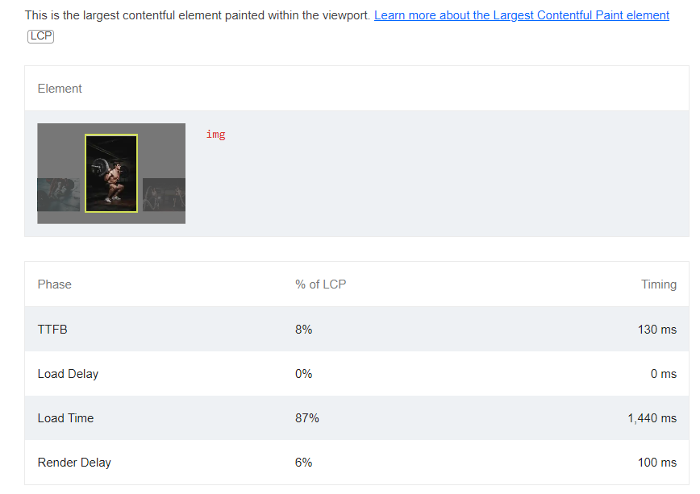

- 5. Serve images in next-gen formats

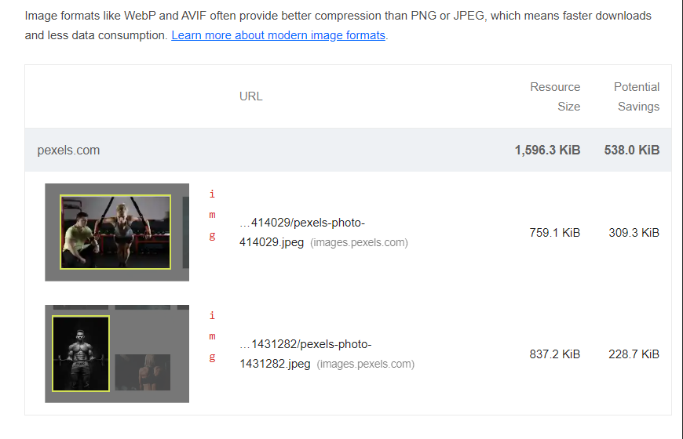

6.Avoid enormous network payloads

